Summary and Key Analysis
Executive Summary
This project analyzes customer churn behavior using exploratory data analysis to understand why customers leave a telecom service. The dataset shows that 26.54% of customers have churned, which highlights a clear retention challenge. The analysis focuses on customer demographics, tenure, service usage, contract types, and payment methods.
The findings show that churn is not influenced by gender, but it is strongly linked to senior citizen status, short tenure, contract type, internet services, and payment methods. Customers who stay longer, use support services, and are on long-term contracts are more likely to remain loyal. These insights help identify high-risk customer segments and areas where service and pricing strategies can be improved.

Key Analysis Summary
- Overall Churn Rate:
26.54% of customers have churned, indicating a significant customer retention gap.
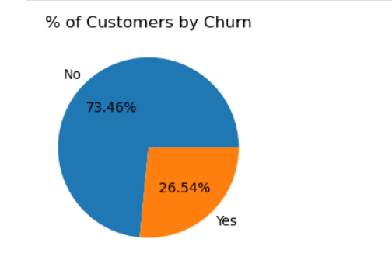
- Gender Impact:
Churn is evenly distributed across genders, showing that gender is not a deciding factor.
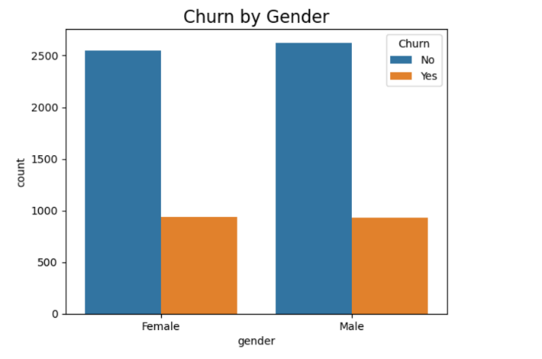
- Senior Citizens:
Although senior citizens represent a smaller portion of customers, a higher percentage of them churn compared to non-senior customers.
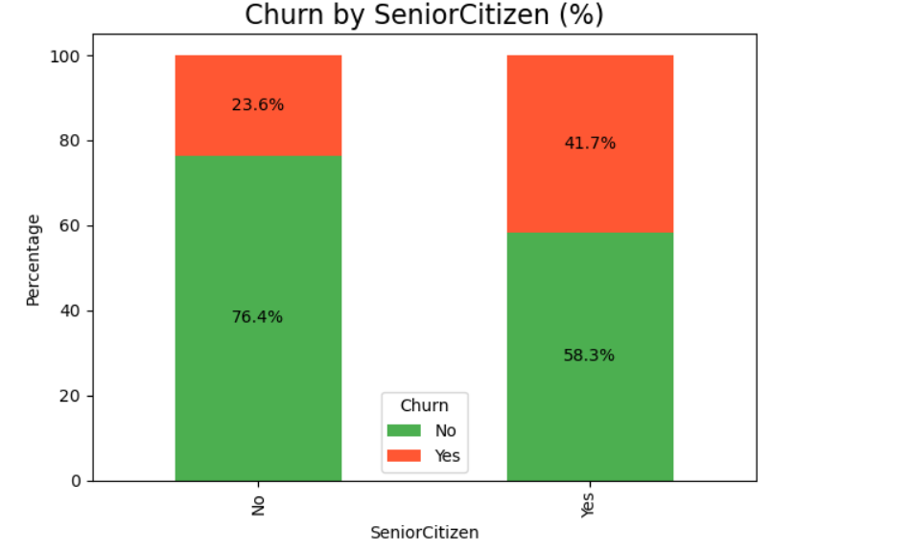
- Tenure Pattern:
Customers with 1–2 months of tenure are more likely to churn, while long-term customers show strong retention.
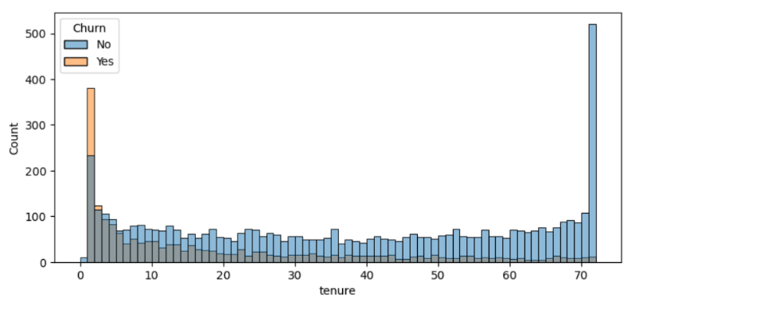
- Contract Type:
Customers on month-to-month contracts churn the most. One-year and two-year contracts show much lower churn rates.
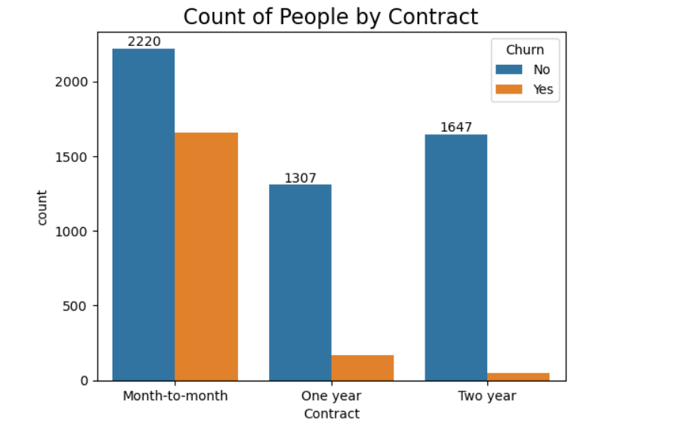
- Internet & Support Services:
Customers without services like Online Security, Tech Support, Backup, and Device Protection are more likely to leave.
Fiber optic users show higher churn, suggesting possible pricing or service quality concerns.
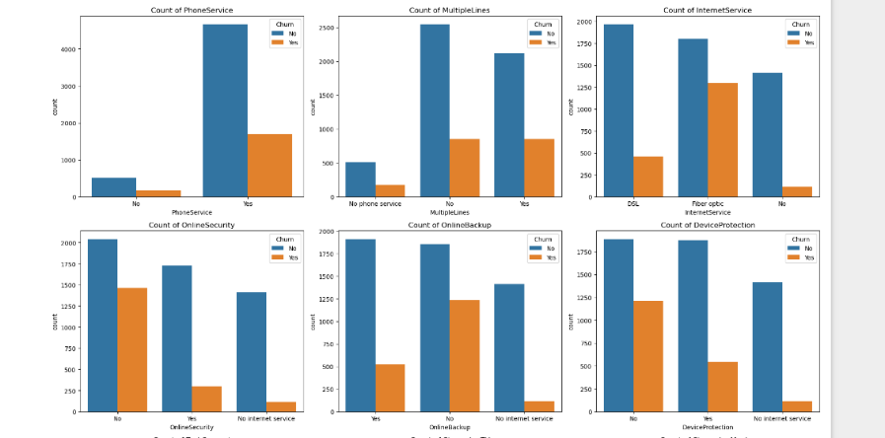
- Payment Method:
Customers using electronic checks have the highest churn rate compared to other payment options.
